QUESTION 2 Notes

Question 1 A

Data Preparation I
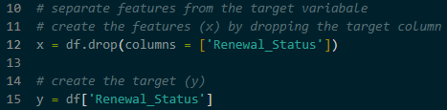
- Action – The Renewal_Status column is moved into a variable called y(the target). All other columns are moved into a variable called x(the features)
- This tells the computer which data it should study (features) and what results it its trying to predict (target)

Data Preparation II
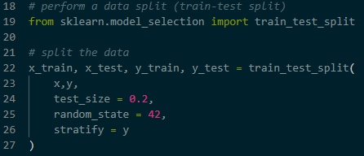
- Action – Use train_test_split with a test size of 0.2 (20%).
- The training set is for learning. The test set is for checking accuracy. Stratifcation ensures that the balance of Renewed vs Not Renewed is equal is both sets so the test is fair

Data Preparation III
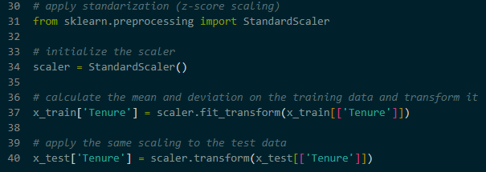
- Using StandardScaler on the Tenure column
- This resizes the number so the average is 0 and the spread is 1. This prevents columns with large numbers from haiving more power over the model than columns with small numbers

Modelling I
- This model creates many individual decision trees and combines their results
- Action – Set n_estimators (number of trees) and max_depth (how deep the trees grow). Using .fit() to start the training
- By using many trees, the model is less likely to make a mistake based on a single unusual piece of data

Modelling II
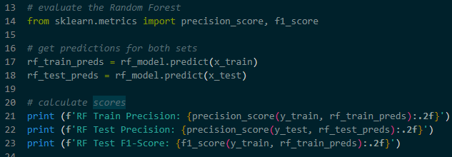
- Using precision_score and f1_score
- Precision : This measures how often the model is correct when it predicts a Renewal
- F1-Score : This measures the total health of the model by combining precision and the ability to find all renewals
- These scores show us if the model is ready to be used in a real business

Modelling III
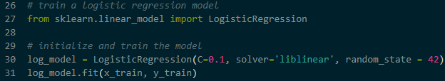
- Action – Set the C value (to control simplicity) and the solver (the math method)
- It is a standard tool for Yes or No questions. It is often faster and easier to explain than a random forest

Modelling IV
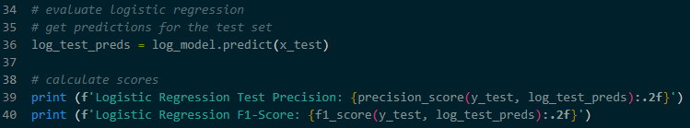
- Using precision_score and f1_score
- Precision : This measures how often the model is correct when it predicts a Renewal
- F1-Score : This measures the total health of the model by combining precision and the ability to find all renewals
- These scores show us if the model is ready to be used in a real business

